Teacher Report
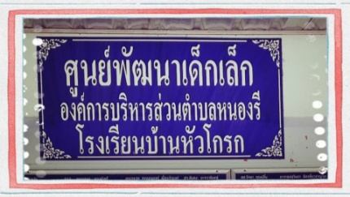
Good morning everyone,

My name is Sutisa Inyom,From Banhourkrong Child care Center,

I'm going to be talking about "Problem of Natthakrit"

The pureposes of this report is to describe Nutthakrit problem he doesn't eat.

The student follows directions and returns homework on time and well done, But every day at school he refused to eat lunch and do not drink milk, Parents say he hardly eat at home.

Should eat different food according to his age.
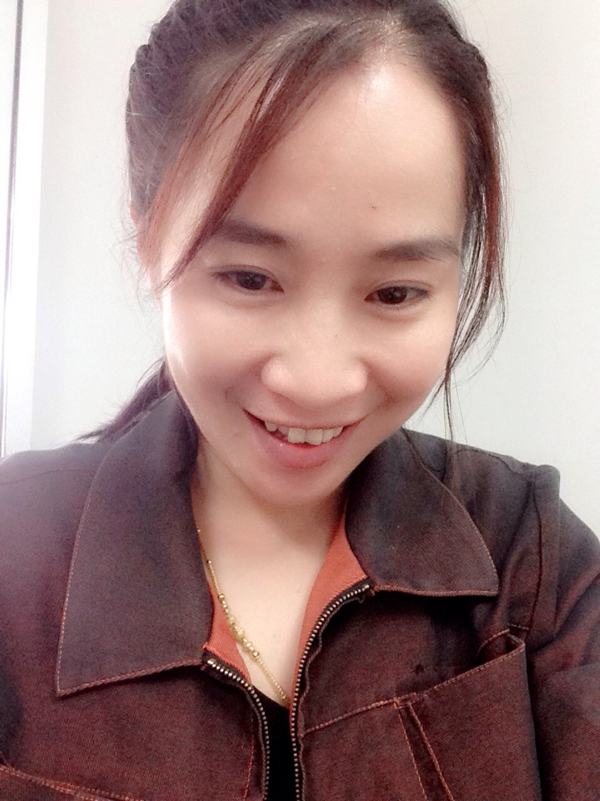
Thank you for listening.

🌷🌷Sutisa Inyom🌷🌷
🌻🌻571761321077🌻🌻
💐Room 2 (11604)💐

